Transform Your Space



Human Computer Interface Course Project Report

in partial fulfilment of the degree

**Bachelor of Technology**

in

**Computer Science & Engineering**

**By**

A.ABHISHEK 2303A51656

B.SAI TEJA 2303A510D1

Under the guidance of

Ms.Faiza Iram

Assistant Professor

**Submitted to**

**School of Computer Science and Artificial Intelligence**





**DEPARTMENT OF COMPUTER SCIENCE & ENGINEERING**

**CERTIFICATE**

This is to certify that the **Human Computer Interface - Course Project** Report entitled **“Transform Your Space”** is a record of bonafide work carried out by the student A.ABHISHEK, B. SAI TEJA bearing Roll No(s) 2303A51656, 2303A510D1 during the academic year 2024-25 in partial fulfillment of the award of the degree of ***Bachelor of Technology*** in **Computer Science & Engineering** by the SR University, Warangal.

**Lab In-charge Head of the Department**

**Table of contents**

1. OBJECTIVE OF THE PROJECT
2. DEFINITIONS OF THE ELEMENTS USED IN THE PROJECT
3. DESIGN
   1. SCREENS
4. IMPLEMENTATION
   1. CODE
5. RESULT SCREENS
6. CONCLUSION

**ABSTRACT:**

“Transform Your Space” aims to revolutionize the interior design industry by providing a seamless, innovative, and personalized virtual design experience for our clients. This project leverages advanced features such as virtual Consultation, 3D Room Design and Space Planning, allowing clients to visualize and customize their living spaces in real-time. By offering Virtual Consultations with experienced interior designers, “Transform Your Space” ensures that clients receive expert guidance and tailored design plans that reflect their unique tastes and needs.

**1. OBJECTIVE:**

The goal of the “Transform Your Space” project is to revolutionize the way customers approach interior design by leveraging the expertise of our experienced interior designers through virtual consultations. Our mission is to offer personalized, professional interior design advice that helps clients reimagine and optimize their living or working spaces.

**Vision:**

To become the leading virtual interior design service provider, known for our creativity, innovation, and commitment to delivering exceptional design solutions that transform spaces and enhance the quality of life for our clients.

**Mission:**

To make professional interior design accessible and convenient for everyone, enabling clients to achieve their dream spaces with the guidance and expertise of experienced designers, all from the comfort of their homes.

2. **DEFINITIONS OF ELEMENTS USED:**

**Virtual Consultation**

Transform Your Space offers virtual interior design consultations that bring professional expertise to your fingertips. Through video calls, clients can discuss their design needs, preferences, and goals directly with expert designers. The consultation includes a detailed review of the space, color schemes, furniture choices, and layout recommendations. Clients receive personalized advice, mood boards, and 3D renderings tailored to their style and budget. Virtual consultations make it easy to design or redesign a space without the need for in-person meetings, offering flexibility, convenience, and professional insights to create functional and beautiful interiors from anywhere.

**3D Room Design**

Transform Your Space offers 3D room design as part of its virtual interior design services, giving clients a realistic preview of their redesigned space. Using advanced software, designers create detailed 3D renderings that showcase layout options, furniture placement, color schemes, and décor elements, allowing clients to visualize their new space before making final decisions.

**Space Planning**

Space planning is a key feature of Transform Your Space's virtual interior design solutions, ensuring that every room is functional, efficient, and aesthetically pleasing. Through careful analysis of the layout, designers optimize the use of available space, taking into account factors like traffic flow, furniture dimensions, and room purpose. The process includes creating detailed floor plans that balance style and practicality, maximizing both comfort and visual appeal. With expert guidance, clients can avoid common design pitfalls and create harmonious spaces that reflect their personal style, all while maintaining functionality in everyday living or working environments.

**3.DESIGN:**

**3.1 SCREENS:**

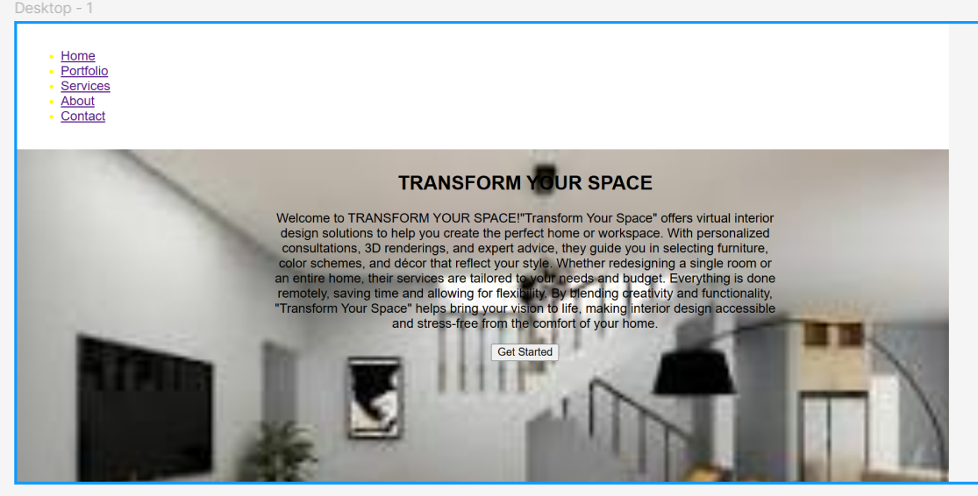

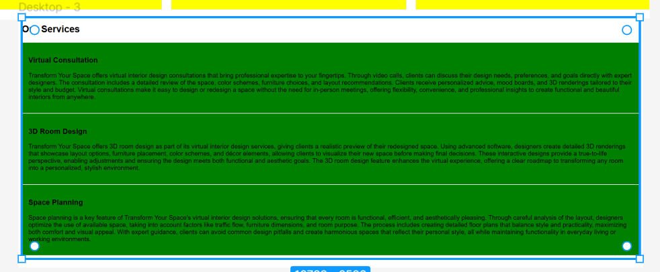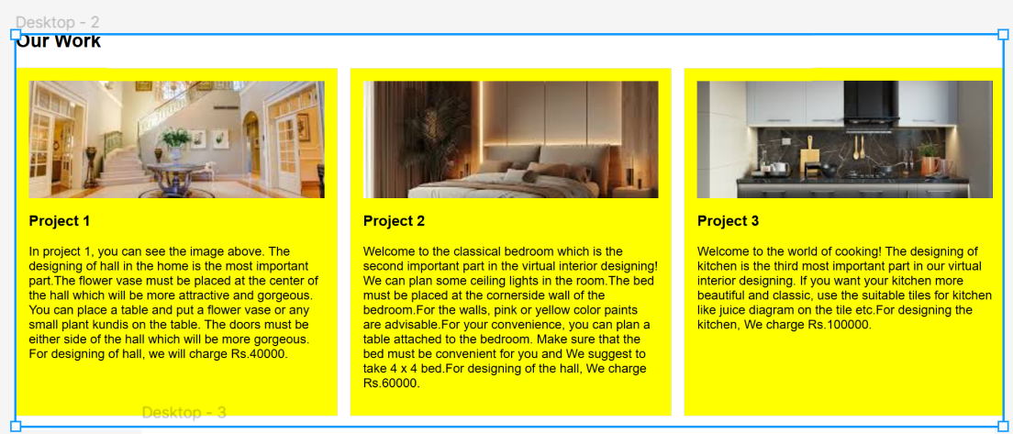 **4. IMPLEMENTATION:**

**4.1 CODE:**

<html lang="en">

<head>

<meta charset="UTF-8">

<meta name="viewport" content="width=device-width, initial-scale=1.0">

<title>Virtual Interior Designing</title>

<link rel="stylesheet" href="(link unavailable)">

<style>

body {

font-family: Arial, sans-serif;

margin: 0;

padding: 0;

}

header {

background-color: white;

color: yellow;

padding: 1em;

text-a

lign: left;

}

.hero-content {

position: absolute;

top: 50%;

left: 50%;

transform: translate(-50%, -50%);

text-align: center;

}

.hero-image {

background-image: url('hero.jpg');

background-size: cover;

height: 100vh;

width: 100%;

}

.portfolio-grid {

display: grid;

grid-template-columns: repeat(3, 1fr);

gap: 1em;

}

.project {

background-color: yellow;

padding: 1em;

border: 1px solid #ddd;

}

.project img {

width: 100%;

height: 150px;

object-fit: cover;

}

.service-card {

background-color:pink;

padding: 1em;

border: 1px solid #ddd;

}

.team-member {

background-color: indigo;

padding: 1em;

border: 1px solid #ddd;

}

.contact-form {

padding: 1em;

background-color:white

}

.footer {

background-color: blue;

color: #fff;

padding: 1em;

text-align: center;

}

</style>

</head>

<body>

<!-- Header Section -->

<header>

<nav>

<ul>

<li><a href="#home">Home</a></li>

<li><a href="#portfolio">Portfolio</a></li>

<li><a href="#services">Services</a></li>

<li><a href="#about">About</a></li>

<li><a href="#contact">Contact</a></li>

</ul>

</nav>

</header>

<section id="home">

<div class="hero-image">

</div>

<div class="hero-content">

<h1>TRANSFORM YOUR SPACE</h1>

<p>Welcome to TRANSFORM YOUR SPACE!"Transform Your Space" offers virtual interior design solutions to help you create the perfect home or workspace. With personalized consultations, 3D renderings, and expert advice, they guide you in selecting furniture, color schemes, and décor that reflect your style. Whether redesigning a single room or an entire home, their services are tailored to your needs and budget. Everything is done remotely, saving time and allowing for flexibility. By blending creativity and functionality, "Transform Your Space" helps bring your vision to life, making interior design accessible and stress-free from the comfort of your home.</p>

<button>Get Started</button>

</div>

</section>

<section id="portfolio">

<h2>Our Work</h2>

<div class="portfolio-grid">

<div class="project">

<img src="project1.jpg" alt="Project 1">

<h3>Project 1</h3>

<p>In project 1, you can see the image above. The designing of hall in the home is the most important part.The flower vase must be placed at the center of the hall which will be more attractive and gorgeous. You can place a table and put a flower vase or any small plant kundis on the table. The doors must be either side of the hall which will be more gorgeous.

For designing of hall, we will charge Rs.40000.</p>

</div>

<div class="project">

<img src="project2.jpg" alt="Project 2">

<h3>Project 2</h3>

<p>Welcome to the classical bedroom which is the second important part in the virtual interior designing! We can plan some ceiling lights in the room.The bed must be placed at the cornerside wall of the bedroom.For the walls, pink or yellow color paints are advisable.For your convenience, you can plan a table attached to the bedroom. Make sure that the bed must be convenient for you and We suggest to take 4 x 4 bed.For designing of the hall, We charge Rs.60000.</p>

</div>

<div class="project">

<img src="project3.jpg" alt="Project 3">

<h3>Project 3</h3>

<p>Welcome to the world of cooking! The designing of kitchen is the third most important part in our virtual interior designing. If you want your kitchen more beautiful and classic, use the suitable tiles for kitchen like juice diagram on the tile etc.For designing the kitchen, We charge Rs.100000.</p>

</div>

</div>

</section>

<section id="services">

<h2>Our Services</h2>

<div class="service-grid">

<div class="service-card">

<h3>Virtual Consultation</h3>

<p>Transform Your Space offers virtual interior design consultations that bring professional expertise to your fingertips. Through video calls, clients can discuss their design needs, preferences, and goals directly with expert designers. The consultation includes a detailed review of the space, color schemes, furniture choices, and layout recommendations. Clients receive personalized advice, mood boards, and 3D renderings tailored to their style and budget. Virtual consultations make it easy to design or redesign a space without the need for in-person meetings, offering flexibility, convenience, and professional insights to create functional and beautiful interiors from anywhere.</p>

</div>

<div class="service-card">

<h3>3D Room Design</h3>

<p>Transform Your Space offers 3D room design as part of its virtual interior design services, giving clients a realistic preview of their redesigned space. Using advanced software, designers create detailed 3D renderings that showcase layout options, furniture placement, color schemes, and décor elements, allowing clients to visualize their new space before making final decisions.</p>

<!-- Add link to open image in a new tab and ensure it fits well -->

<a href="3D Room Design.jpg" target="_blank">

<img src="3d design.jpg" alt="3d design" style="width:50%; height:auto; display:block; margin-top:1em;">

</a>

</div>

<div class="service-card">

<h3>Space Planning</h3>

<p>Space planning is a key feature of Transform Your Space's virtual interior design solutions, ensuring that every room is functional, efficient, and aesthetically pleasing. Through careful analysis of the layout, designers optimize the use of available space, taking into account factors like traffic flow, furniture dimensions, and room purpose. The process includes creating detailed floor plans that balance style and practicality, maximizing both comfort and visual appeal. With expert guidance, clients can avoid common design pitfalls and create harmonious spaces that reflect their personal style, all while maintaining functionality in everyday living or working environments.</p>

</div>

</div>

</section>

<!-- About Section -->

<section id="about">

<h2>About Us</h2>

"Transform Your Space" offers virtual interior design solutions to help you create the perfect home or workspace. With personalized consultations, 3D renderings, and expert advice, they guide you in selecting furniture, color schemes, and décor that reflect your style. Whether redesigning a single room or an entire home, their services are tailored to your needs and budget. Everything is done remotely, saving time and allowing for flexibility. By blending creativity and functionality, "Transform Your Space" helps bring your vision to life, making interior design accessible and stress-free from the comfort of your home.

<section id="contact">

<h4>Contact Us</h4>

<p> For more details:

Email id: transformspace@gmail.com

Contact : 9381098005, 9550863852</p>

**5. RESULT SCREENS:**

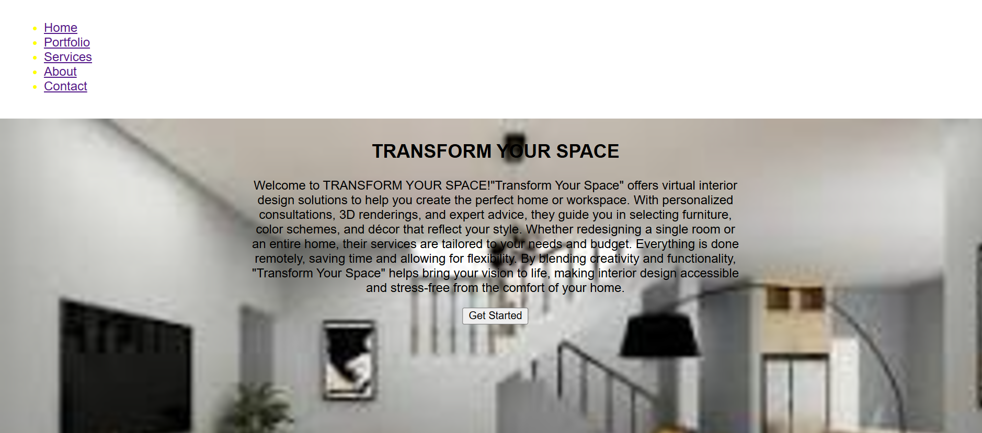

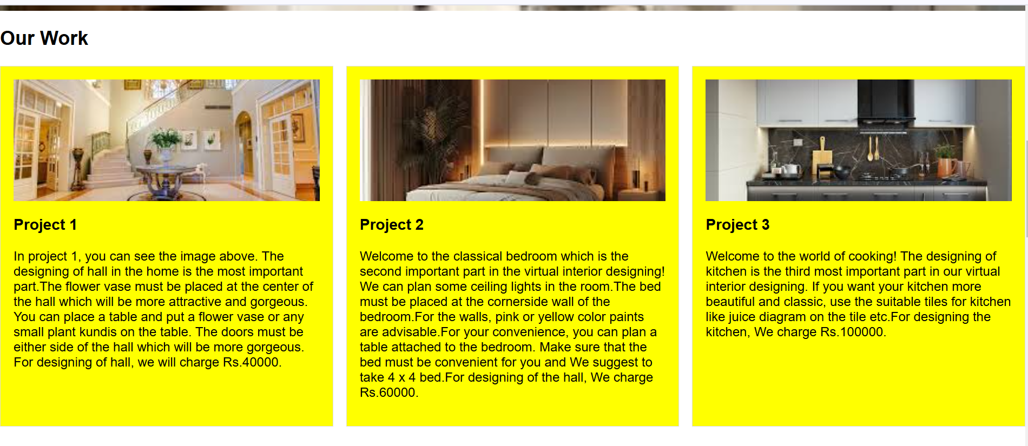

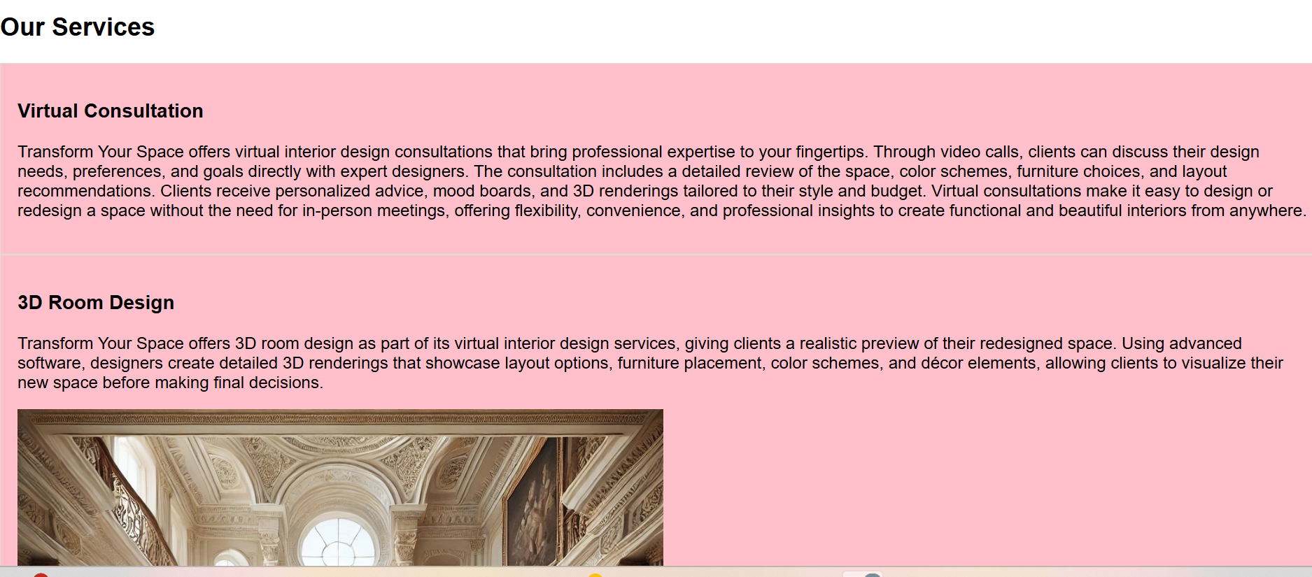

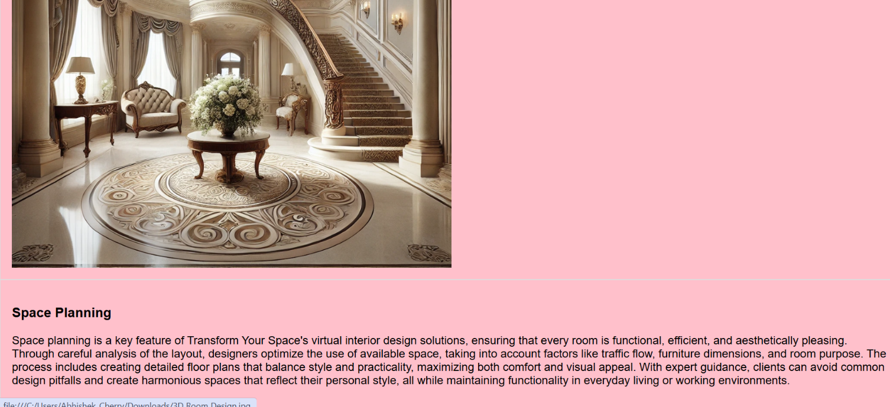

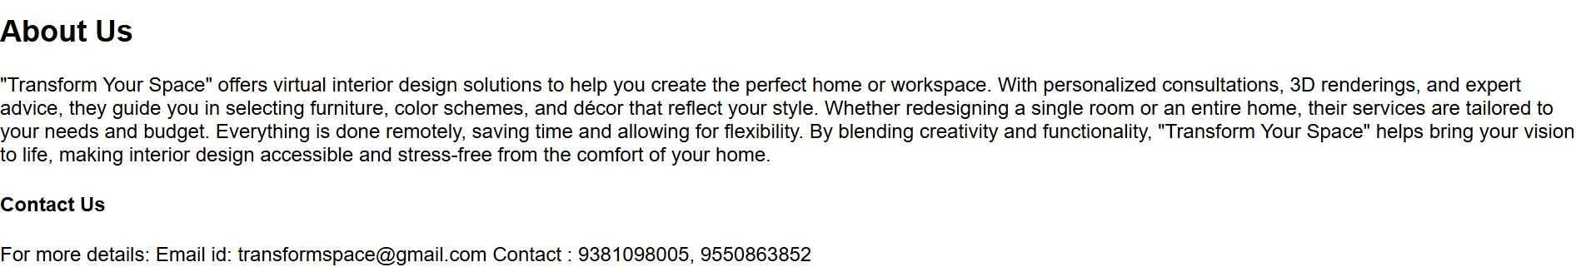

**6.CONCLUSION:**

The "Transform Your Space" project is a pioneering initiative designed to bring professional interior design services to customers in a convenient and innovative way. By leveraging virtual consulta-tions, and the expertise of the experienced interior designers, the project aims to revolutionize the interior design industry and make personalized design accessible to everyone.